**Student’s Project**

**MOROCCO**



**A new vision to convert the students’ footsteps at school into electricity**

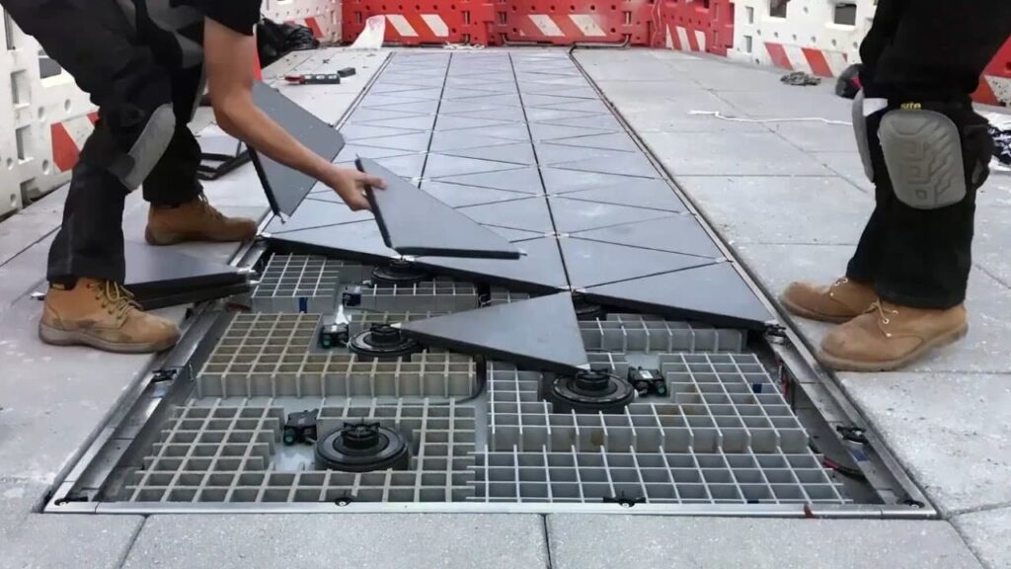

**The researcher : Boulangas Kaoutar**

Supervised by : Prof. Mohamed Fettah

School: Moulay Ismail High School

**Outline**

1. **Part One (Theory) ...........................................................**
2. **Introduction.**
3. Project overview.
4. Benefits of piezoelectric technology.
5. Examples of piezoelectric technology in use.
6. **The use of piezoelectric technology in public places.**
7. Energy conversion and usage.
8. Analysis of existing data and statistics.
9. **The use of piezoelectric technology in schools.**
10. Measures to provide piezoelectric technology at school.
11. Calculations of energy generation.
12. Modeling piezoelectric technology.
13. **Part Two (Practice) ........................................................**

* **Share informative posters about my research.**
* **Make a video for sharing my own vision on piezoelectric technology.**

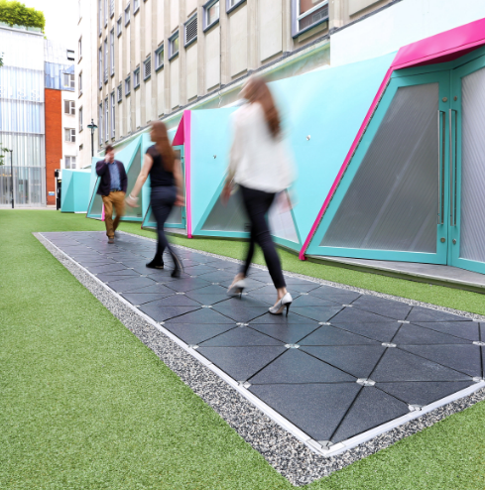

**Abstract**

**Piezoelectric technology becomes a fascinating innovation in energy conversion. It offers significant potential to produce mechanical energy and convert it into electrical power. This research explores the benefits and applications of this technology, particularly in public places and schools. Indeed, piezoelectric technology has been employed in various industries, from powering small electronic devices to integrating with large-scale systems to enhance sustainability. Its ability to generate energy from pressure and vibrations presents an innovative solution to address energy needs in diverse settings.**

**Obviously, the public spaces provide an excellent opportunity to implement piezoelectric technology through making use of the constant movement of people and vehicles. For instance, piezoelectric devices can be installed in sidewalks, train stations, and highways to capture energy from footsteps and vehicular vibrations. This energy can be redirected to power lighting, displays, or other infrastructure. For instance, schools are a good place for the application of piezoelectric technology. Meantime, educational institutions are the right place for raising awareness about renewable energies. Piezoelectric technology can be installed in hallways or playgrounds to harness the energy from students’ movements. This energy can be used to power classroom equipment or lighting, promoting energy efficiency and sustainability.**

**In addition, the implementation of piezoelectric technology in schools involves precise calculations and modeling to optimize energy generation. By analyzing factors such as foot traffic patterns and material efficiency, schools can estimate the energy output and determine the cost-effectiveness of the technology. Additionally, modeling helps to visualize how piezoelectric systems can be integrated with existing infrastructure, ensuring a seamless and impactful adoption. Such measures not only support energy goals but also serve as an educational tool, engaging students in discussions about renewable energy and innovation.**

**Ultimately, piezoelectric technology holds immense potential to revolutionize energy use in both public places and schools. By capturing energy from everyday movements, it provides a sustainable, innovative solution to meet energy demands while fostering environmental consciousness.**

"The environment is a trust given to us by the Creator, and it is our duty to use its resources wisely and preserve them for future generations."

Al-Jahiz